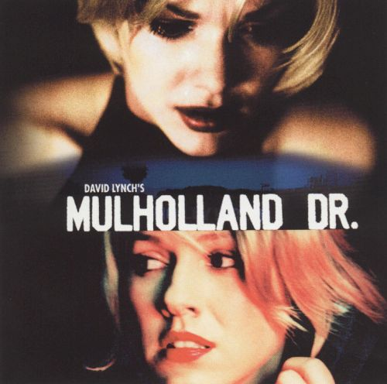

English Lit 500: Psychoanalysis and Lit Fall 2019
MWF 2pm

Psychoanalytic writing and film from a variety of cultures

Includes films, novellas, short stories and poetry from Africa, England, Russia, Germany and the US

Credits: GEC in Writing, English Major and Minor, English Literature, and the Certificates in Gender, Sexuality, and Women's Studies as well as African, Global, Russian/East European/Eurasian Studies, and European Studies

For more info contact Carol Bové—cbove@pitt.edu

