University of Pittsburgh, Department of Psychology
2018-2019 Colloquium Series Fall 2018

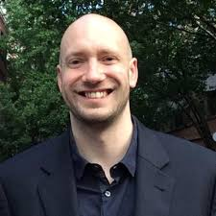
September 14 – Ed Orehek, Ph.D.
https://edwardorehek.wordpress.com/
Assistant Professor of Psychology, University of Pittsburgh.

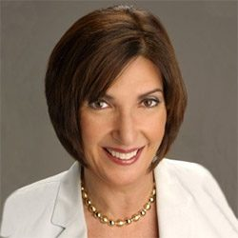
September 28th – Deborah Beidel, Ph.D.
https://sciences.ucf.edu/psychology/people/beidel-deborah-c/
Pegasus Professor of Psychology and Medical Education, University of Central Florida

October 5th – Aidan Wright, Ph.D.
http://www.personalityprocesses.com
Assistant Professor of Psychology, University of Pittsburgh

January 18 – Martha Farah, Ph.D.
https://neuroethics.upenn.edu/martha-j-farah-phd/
Walter H. Annenberg Professor in Natural Sciences, University of Pennsylvania

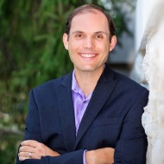
March 1st – C. Nathan DeWall, Ph.D.
http://www.nathandewall.com/about
Professor of Psychology, University of Kentucky

March 29th – Harriet De Witt, Ph.D.
http://hbpl.uchicago.edu/
Professor, Department of Psychiatry, University of Chicago

